

MATES Computer Science

**Senior Capstone Project Bi-Weekly Progress Report**

| Project Title | Journal Time! |
| --- | --- |
| Team Members | Shayne Lada, Ava McNabb, Lauren McNaboe |
| Dates Covered by Report | 4/22/24 - 5/03/24 |
| Link to Github | <https://github.com/code-shayne/journal-time-/tree/main> |

# **Summary of Project**

Journal Time! is a web app that allows users to journal and store entries online. The web app would provide prompts or free-journaling options and save all entries to unique user accounts. Users can also track emotions by indicating what they are feeling at the time of journaling. After each entry the user will receive a certain number of points or currency, incentivising journaling. The points can be used to buy accessories within the website such as different prompt packages, website themes, or journaling pets. The journaling pets would be avatars that live on the interface and encourage the user to journal and provide motivational messages. Points could also be used to customize and feed/play with pets. Users can track their journaling progress and view graphs and summaries of their emotions in a separate space on the web app. Email notifications can be scheduled to remind the user to journal or sent if the account hasn’t been used for 2 weeks. This project will encourage journaling, which is a useful practice for mental health and wellbeing. It will also make the process more accessible and fun for the users.

1. Summary of Progress this Period

A lot of the work done this period was fixing small issues and adding more aesthetic things to the shop. We were working on small things awaiting the SQL database.

# **Detailed Progress this Period, separated by Team Member**

Lauren -

* login/reset page: ITS FINALLY DONE!!!!! The issue was that the reset section was in the same div as the login and signup pages. I don’t know why taking it out fixed the problem but I am very happy that it is fixed.
* random prompts: I took Shayne’s sheet with the prompts on it, split it into different workbooks (is that what they’re called? idk the different pages) and tried to upload them through an xlsx package through JavaScript. That didn’t work, so I ChatGPT’d it and it told me to convert to a JSON file. I tried an online converter but it didn’t work with the multiple pages on the file. So I decided to put everything in by hand… yay! In the end it worked so I was very happy.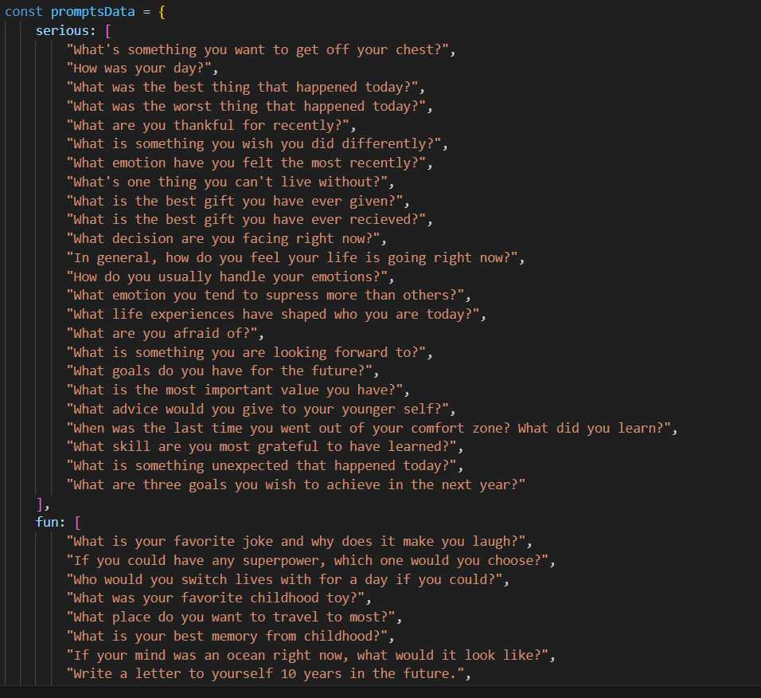
* shop items & pictures: since I don’t have a SQL database yet, I can’t do much to add functionality to everything I’ve done. I added pictures and additional pets to the shop section 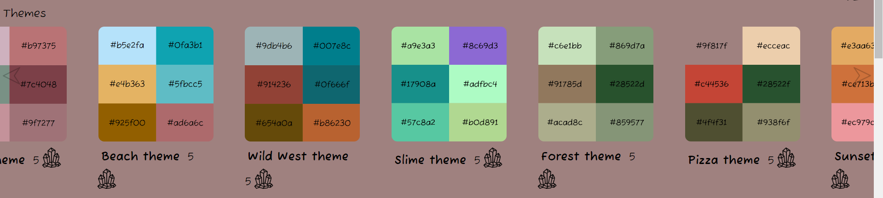
* 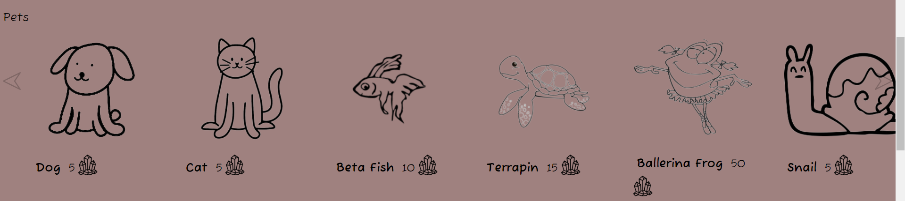ballerina frog and cat are my favorite
* hosting the website: I took all of the files and uploaded them to my own repository. I read that the repository had to be called username.github.io, but apparently it doesn’t? Still, the custom domain name doesn’t work. Right now, the website is hosted on [code-shayne.github.io/journal-time-](http://code-shayne.github.io/journal-time-) if you want to take a peek

Shayne -

* themes: I worked on and created multiple different theme colors. I also created a new JavaScript function to change between the themes that no longer requires separate css sheets for each theme. The way it works is by selecting all the variables in the main style sheet and changing them to a different hex code for each theme. Then, when the button is clicked it calls the function to change all the variables until a different theme button is selected, ensuring that the theme persists when the page is reloaded or changed.

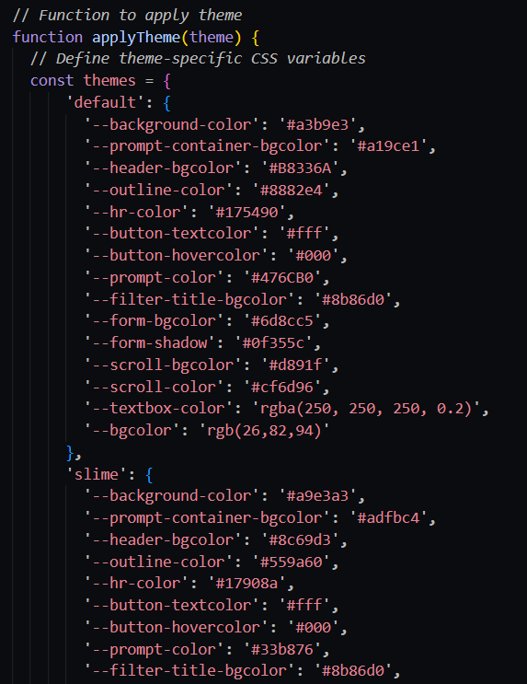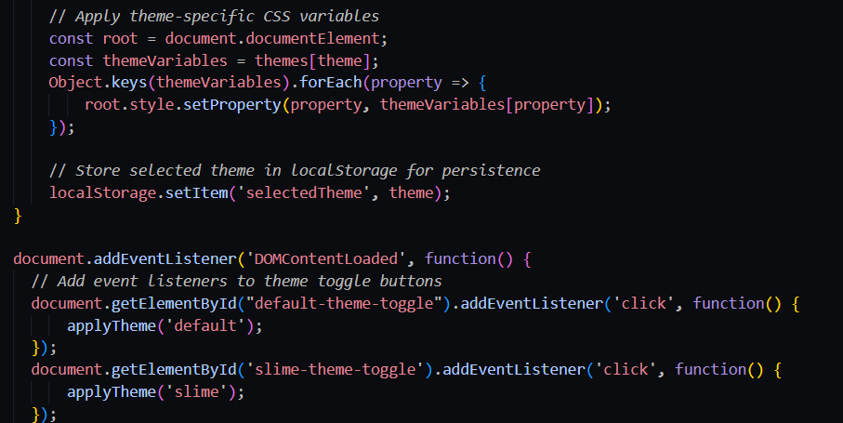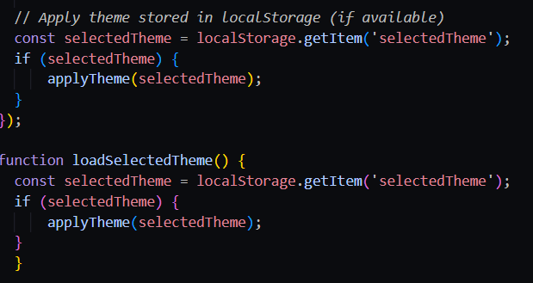

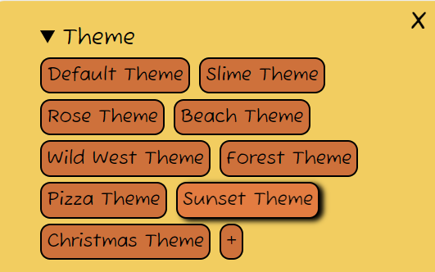These are all the themes we have so far

* prompts: I created a Google sheet to start creating prompts that could be generated. I wrote/found a lot of different prompts in 5 different categories. In the future we will probably utilize AI to generate a lot more prompts for many different categories but this was just a basis to test how to apply the random generation to the web app. Lauren created a function to do that and the prompts now generate randomly based on which category is selected.
* GitHub pages: I hosted Journal Time! on GitHub pages which was actually much simpler than we thought it was. I think the issue before could have been that Lauren was attempting it but I own the repository so it only let me do it. You can find the website at <https://code-shayne.github.io/journal-time->
* notifications: I added a new section to the settings tab for notifications. This will be where the user can set email notifications and control their frequency. I added a toggle switch to turn notifications on or off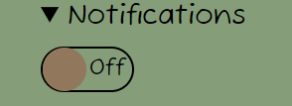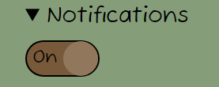
* store items: I replaced the placeholder items in the theme section of the store with actual options. The product image shows the colors used in the theme and the label is the name of the theme. Lauren also made some of these based on the color template I used. I also changed the text that said crystals to the image, but this causes some of them to go to the next line weirdly so I have to fix this in the future. My next task for this will be making separate product description pages where it will show the theme applied to the website and allow the user to purchase it. 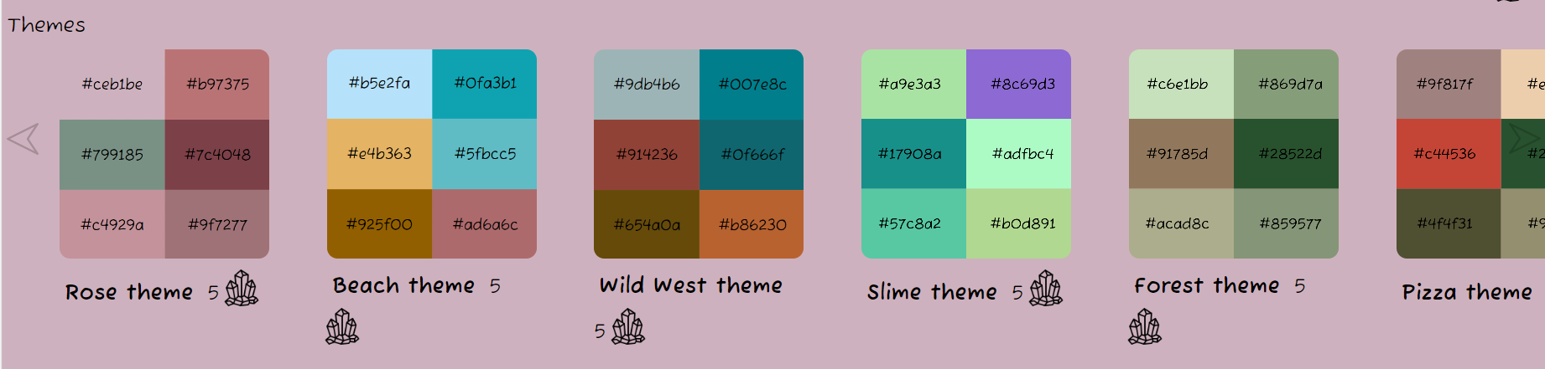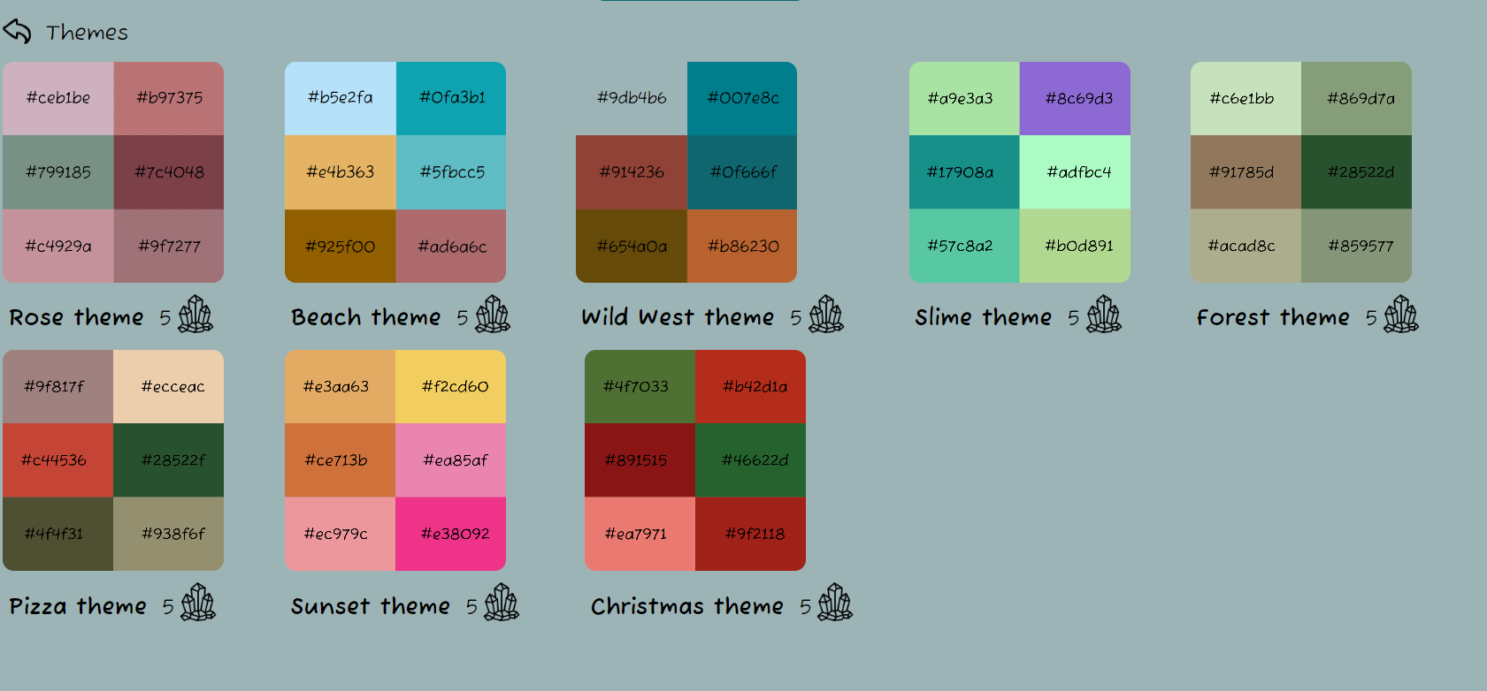

Ava -

* MySQL Workbench and XAMPP setup
  + downloaded and installed
* Created SQL server
* Debugged existing SQL code
  + minor syntax errors
  + tested creating tables and adding data
* PHP Codecademy course
  + Intro to PHP and Skill Path
* Created index.php to begin writing functions

# **Difficulties Encountered this Progress Period**

There was some confusion with GitHub pages but we resolved that pretty easily. There are also weird issues with the style sheets. Sometimes different features are applied/not applied and Lauren or Shayne’s code is changed or doesn’t work anymore. Both of us are pulling and pushing our changes to the repository so we don’t know why this is happening.

# **Updated Trello Board and Discussion**

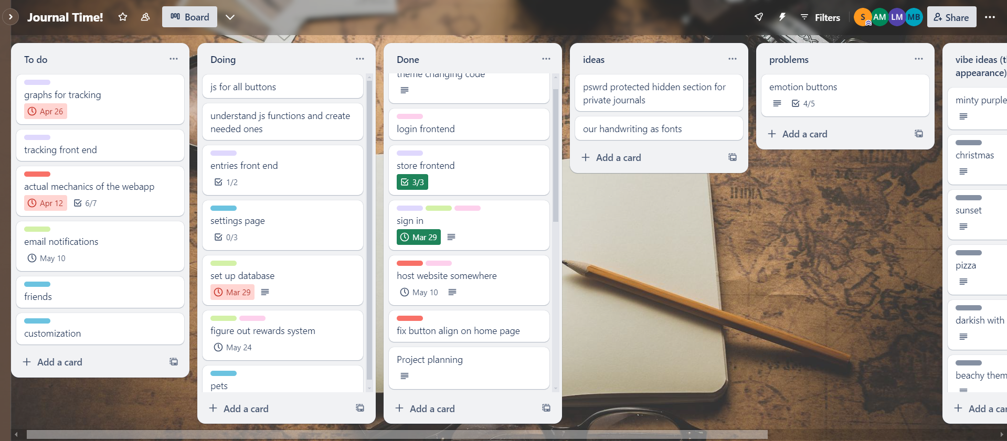

<https://trello.com/b/5P60HsFp>

The ‘vibe ideas’ section was updated to include more themes and also show which ones have already been implemented. Other tasks were also moved around based on their completeness.

# **Tasks to Be Worked on in Next Progress Period** **Lauren** -

* connect login page with SQL database
* figure out rewards systems with SQL database/JS
* storing everything in the database (themes, rewards, login info, etc.)
* settings page? possibly

Shayne -

* Create more prompts/an efficient way to create many at once
* store product descriptions
* store product images for prompt packages
* figure out email notification system

Ava -

* hosting SQL server
* finishing PHP to connect HTML form to database
* expanding the database to include rewards info, email settings, etc.

# **Additional Information**

A lot of the big things we need to accomplish still require connections to SQL databases that are not set up yet, so Lauren and Shayne are focusing a little more on aesthetics and smaller features while that is getting set up.